# File permissions in Linux

## Project description

## In this project, I used Linux commands to verify and modify file and directory permissions, ensuring that only authorized users have access. Using the ls -la command, I analyzed the current permissions and, when necessary, applied chmod to correct them. Additionally, I adjusted permissions for hidden files and restricted access to sensitive directories.

## Check file and directory details

ls -la /home/researcher2/projects

## Describe the permissions string

One example of a file permission string from the output of ls -la is:  
  
drwxr-xr-x 3 researcher2 research_team 4096 Feb 18 12:18 projects  
d-> Indicates that this is a directory.  
rwx -> indicates de “user” (researcher2) has read (r), write (w), and execute (x) permissions

r-x -> the “group” (research_team) has read ® and execute (x) permissions.  
r-x -< “others” same as “group”

## Change file permissions

Since the organization does not allow "others" to have write permissions, the file .project_k.txt has incorrect permissions.  
chmod o-w project.k.txt

## Change file permissions on a hidden file

The research team has archived **.project_x.txt**, which is why it’s a hidden file. This file should not have write permissions for anyone, but the user and group should be able to read the file.   
chmod u-w, g-w .project_x.txt to remove write permissions from user and group

## Change directory permissions

The files and directories in the projects directory belong to the **researcher2** user. Only **researcher2** should be allowed to access the **drafts** directory and its contents.  
chmod g-x /home/researcher2/projects/drafts  
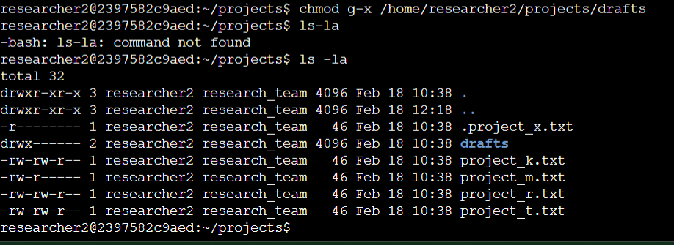

## Summary

In this project, I examined file and directory permissions using the ls -la command and made necessary modifications to ensure security. I used chmod to remove write access from "others" on sensitive files, set read-only permissions for the hidden file .project_x.txt, and restricted access to the drafts directory. These changes help maintain data integrity and limit unauthorized access within the system.